CS 340 Project Two
Grazioso Salvare Rescue Animal Dashboard
Mason Butler

About the Project
This project is a web-based dashboard developed for Grazioso Salvare, an international rescue animal training organization. The purpose of the dashboard is to help identify dogs from the Austin Animal Center dataset that may be suitable for different types of search-and-rescue training.
In Project One, I developed a MongoDB database and a reusable Python CRUD module that allows applications to create, read, update, and delete animal records. For Project Two, I expanded that functionality by creating an interactive dashboard that allows users to search, filter, and visualize animal shelter information.
The dashboard provides a way for Grazioso Salvare to identify potential rescue dogs without having to manually search through thousands of database records.

Dashboard Functionality
The dashboard allows users to view animal shelter records and filter them based on specific rescue-training requirements. The interface contains four filtering options: Water Rescue, Mountain or Wilderness Rescue, Disaster or Individual Tracking, and Reset.
Each rescue filter searches the MongoDB database using the preferred breeds, sex, and age requirements provided by Grazioso Salvare. When a filter is selected, the dashboard updates the data table, breed chart, and geolocation map to reflect the matching records.
The interactive data table includes pagination, sorting, and additional filtering options to make the information easier to navigate. The dashboard displays ten records per page to prevent users from becoming overwhelmed by the amount of information.
I also included a bar chart that displays the ten most common breeds within the selected results. This helps users understand which breeds are represented in each rescue category. The geolocation map displays the location of the selected animal using coordinates from the database.
The dashboard includes the Grazioso Salvare logo, which links to the SNHU website, and my name as the unique identifier required for the project.

Rescue Selection Criteria
The rescue filters were developed using the requirements provided in the Dashboard Specifications Document.
Water Rescue
The preferred breeds are Labrador Retriever Mix, Chesapeake Bay Retriever, and Newfoundland. The preferred sex is intact female, and the training age is between 26 and 156 weeks.
Mountain or Wilderness Rescue
The preferred breeds are German Shepherd, Alaskan Malamute, Old English Sheepdog, Siberian Husky, and Rottweiler. The preferred sex is intact male, and the training age is between 26 and 156 weeks.
Disaster or Individual Tracking
The preferred breeds are Doberman Pinscher, German Shepherd, Golden Retriever, Bloodhound, and Rottweiler. The preferred sex is intact male, and the training age is between 20 and 300 weeks.
The dashboard uses MongoDB queries to identify animals matching these requirements. Case-insensitive regular expressions allow the application to recognize matching breed names, including mixed breeds.

Tools and Technologies Used
MongoDB
MongoDB was used as the database system because it stores information in flexible documents rather than traditional relational tables. This makes it useful for storing animal shelter records containing different characteristics, such as breed, age, sex, and location. MongoDB also supports queries that allow the application to retrieve specific animals based on the rescue requirements.

Python and PyMongo
Python was used to develop the application and connect its components. PyMongo provides the connection between Python and MongoDB, allowing the application to perform database queries.
I reused my CRUD Python module from Project One, which contains the AnimalShelter class and methods for creating, reading, updating, and deleting records. For this dashboard, the read method retrieves animal records based on the selected rescue filter.
Dash and JupyterDash
Dash was used to create the web-based dashboard. It provides interactive components such as radio buttons, tables, and charts. JupyterDash allows the application to run within the Jupyter Notebook environment provided by Codio.
Dash callbacks allow different components of the dashboard to communicate with one another. When a user changes the selected filter, the application automatically updates the displayed results.
Pandas
Pandas was used to convert MongoDB query results into DataFrames. This makes the records easier to organize and display in the interactive data table and charts.
Plotly Express
Plotly Express was used to create the bar chart displaying the most common animal breeds. The chart automatically changes when the user selects a different rescue category.
Dash Leaflet
Dash Leaflet was used to create the geolocation map. It displays the location of a selected animal using its latitude and longitude coordinates from the database.
Model-View-Controller Design
The dashboard follows the Model-View-Controller (MVC) design pattern.
The model consists of the MongoDB database and the AnimalShelter CRUD module. These components are responsible for storing, retrieving, and managing animal records.
The view consists of the dashboard interface, including the filtering options, interactive data table, breed chart, and geolocation map.
The controller consists of the Dash callback functions. These functions receive user input, execute the appropriate database queries, and update the dashboard components.
Separating these responsibilities makes the application easier to maintain and allows future developers to update individual components without rewriting the entire program.

Getting Started and Installation
The application was developed and tested using the SNHU Codio environment.
To reproduce the project, a user needs access to Python, Jupyter Notebook, MongoDB, and the required Python libraries.
The following steps explain how to set up and run the application.
1. Install or access MongoDB and create a database named `aac` with a collection named `animals`.
2. Import the Austin Animal Center shelter outcomes CSV file into the MongoDB collection.
3. Create a MongoDB user named `aacuser` with readWrite permissions for the `aac` database.
4. Install the required Python libraries, including PyMongo, pandas, Dash, JupyterDash, Plotly, Dash Leaflet, NumPy, and Matplotlib.
5. Place `ProjectTwoDashboard.ipynb` and `CRUD_Python_Module.py` in the same directory.
6. Add the Grazioso Salvare logo image to the same directory and ensure its filename matches the filename referenced in the notebook.
7. Update the database username and password in the dashboard code to match the MongoDB account.
8. Open `ProjectTwoDashboard.ipynb` in Jupyter Notebook and execute the code.
9. Open the dashboard using the provided Codio URL on port 8050.
Once the application is running, users can select the different rescue filters to view matching animals. Selecting an individual record in the table updates the geolocation map.
For security, actual database passwords should not be included when publishing the project to a public GitHub repository.

Testing and Results
After completing the dashboard, I tested each filtering option to verify that the data table, breed chart, and geolocation map responded correctly.
The initial dashboard successfully retrieved 20,000 animal records from MongoDB. Each rescue filter reduced the results based on the selected requirements. The Reset option successfully restored the original unfiltered dataset.

Initial Dashboard
The initial dashboard displays all 20,000 animal records. The interactive table, breed chart, and geolocation map are visible before applying any rescue filters.

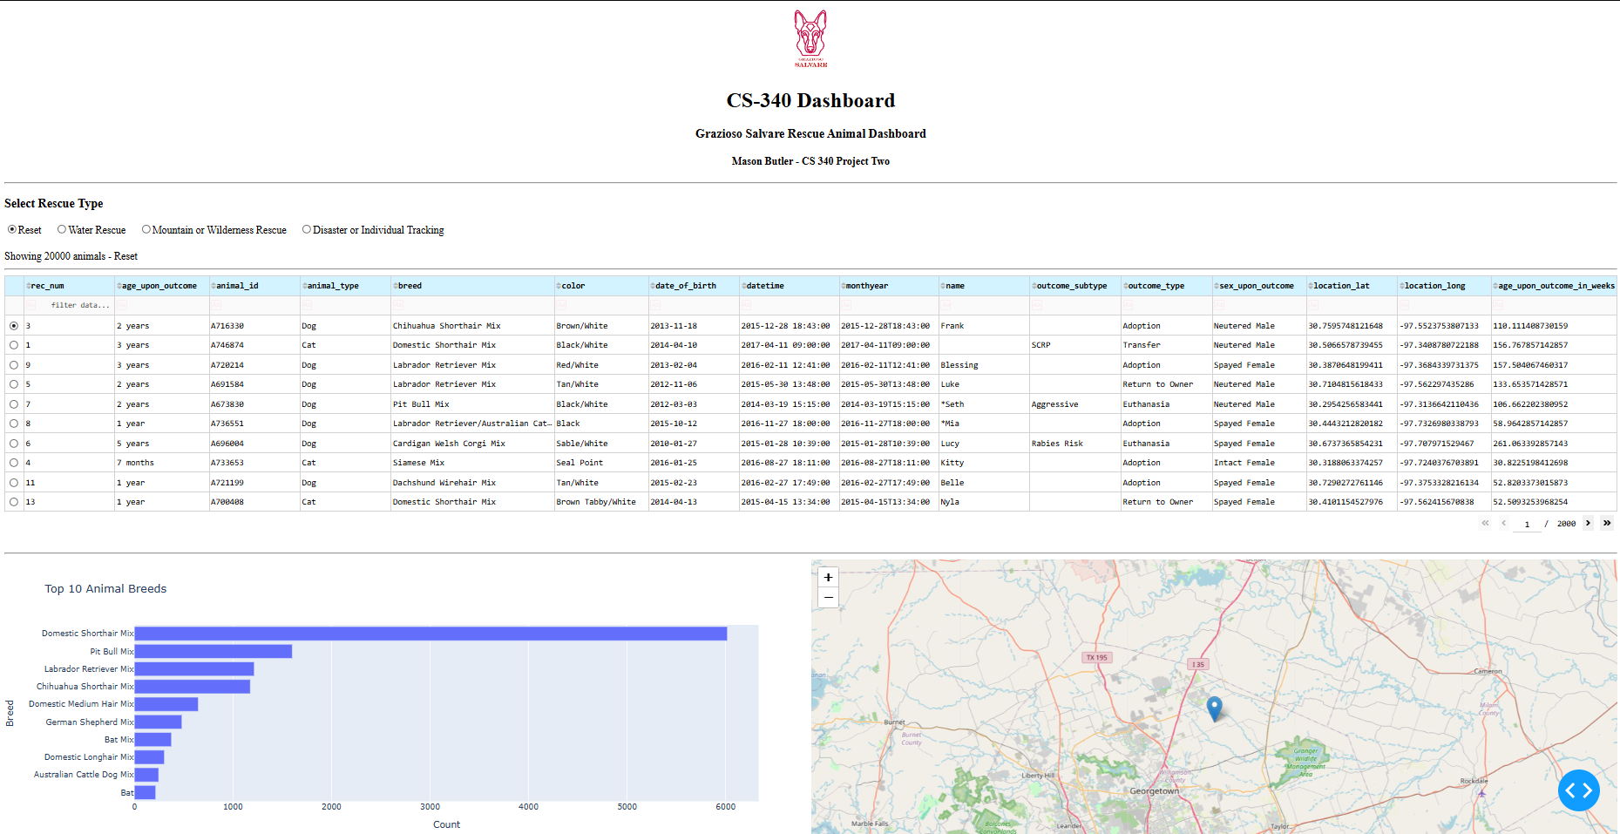

Water Rescue
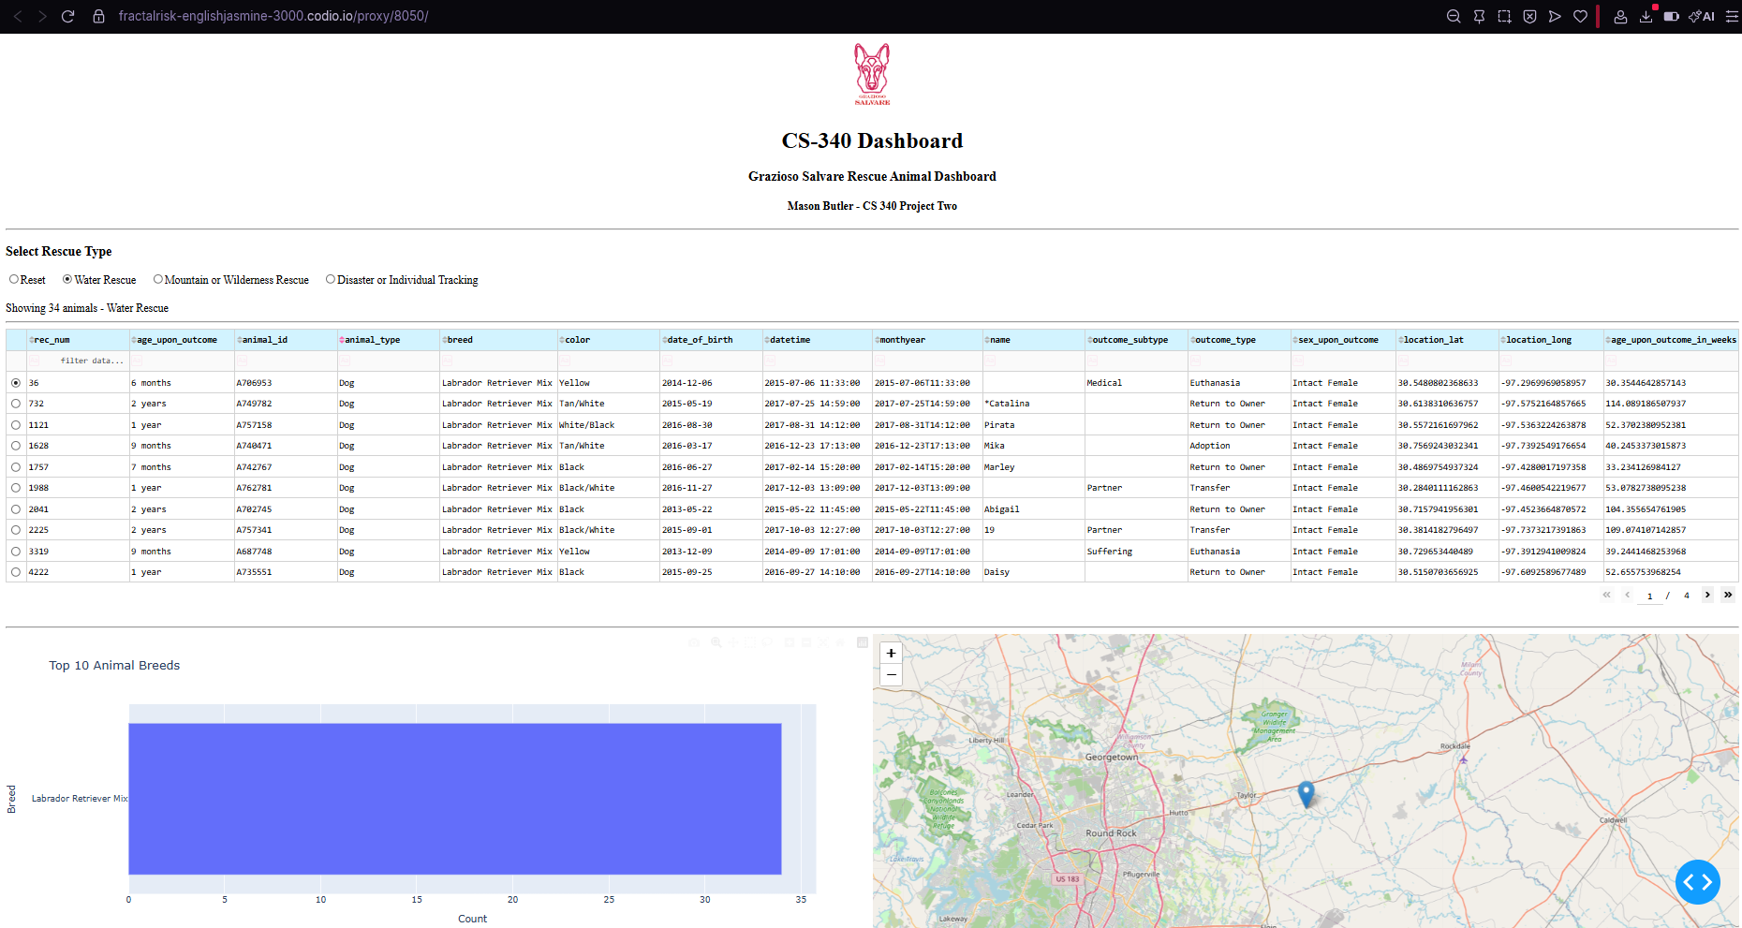
Selecting Water Rescue returned 34 matching animal records. The table displayed animals matching the water rescue requirements, and the breed chart updated to reflect the filtered results.

Mountain or Wilderness Rescue
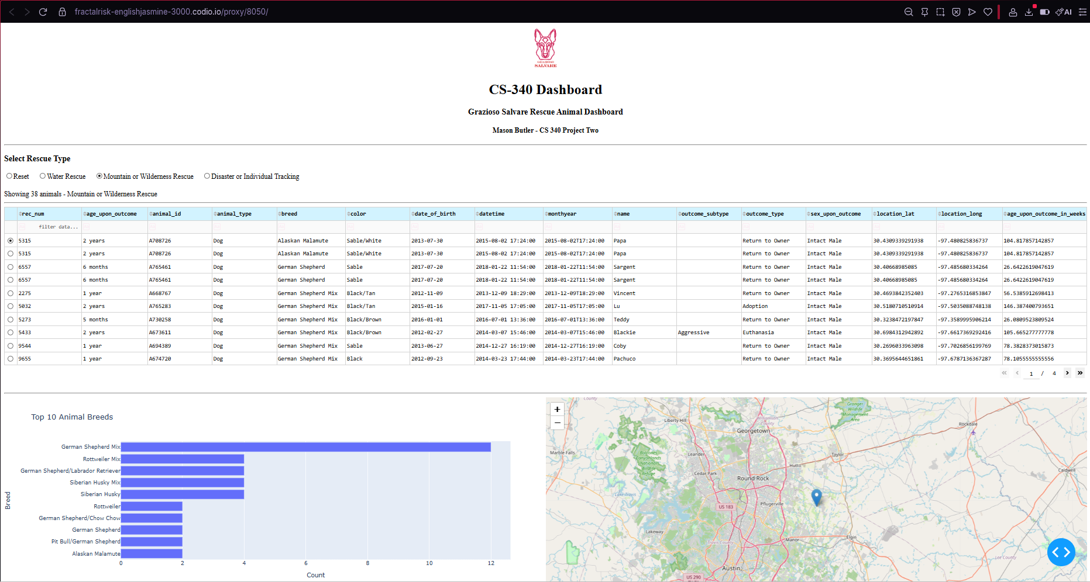
Selecting Mountain or Wilderness Rescue returned 38 matching animal records. The table displayed breeds such as German Shepherd and Alaskan Malamute, while the breed chart and map updated.

Disaster or Individual Tracking
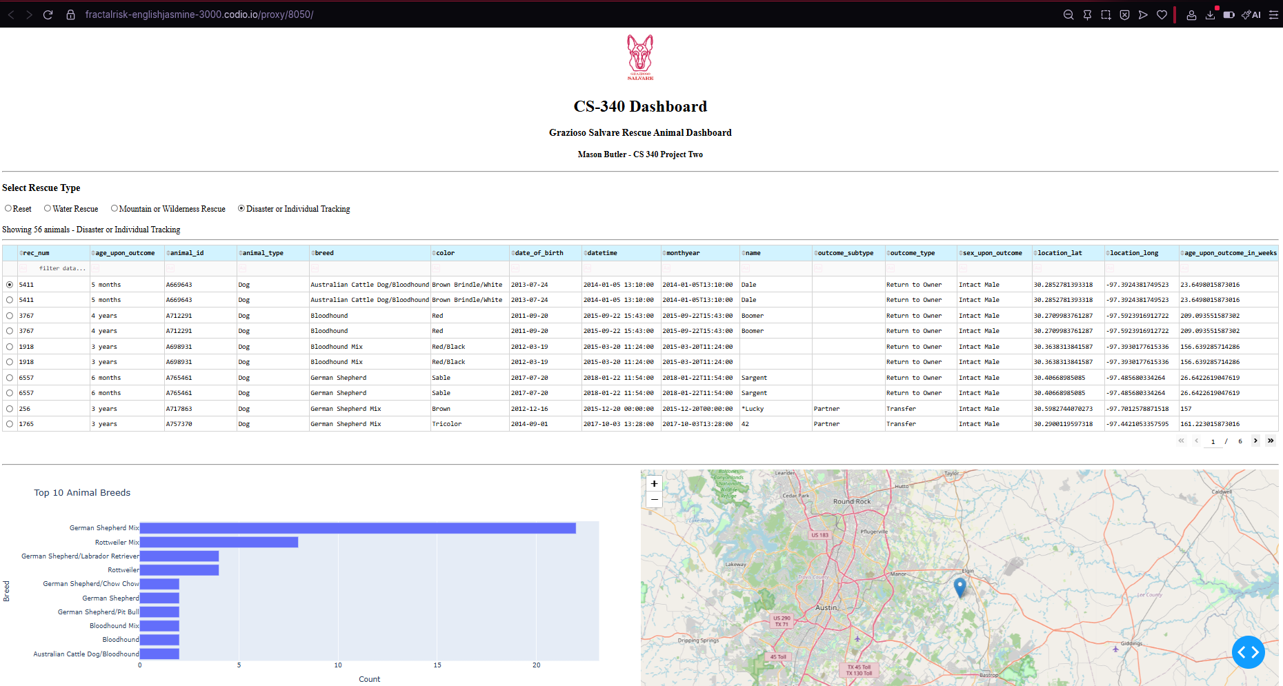
Selecting Disaster or Individual Tracking returned 56 matching animal records. The results included breeds such as Bloodhound and German Shepherd, and the dashboard updated the visualizations.
Reset Functionality
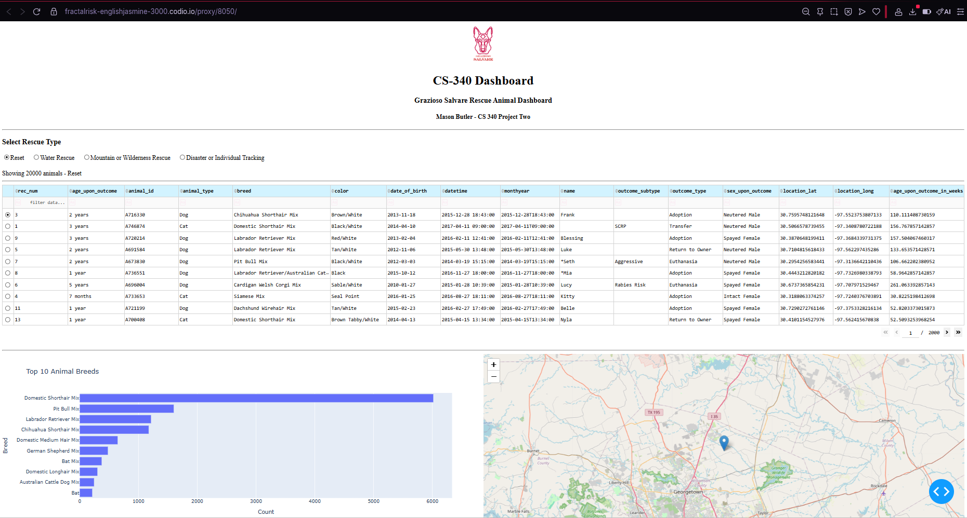
Selecting Reset restored all 20,000 animal records and returned the dashboard to its original unfiltered state.
These tests demonstrated that the application could retrieve animal records from MongoDB and dynamically update the dashboard based on user selections. The record counts reflect the database contents at the time of testing.

Challenges and Solutions
One challenge I encountered was connecting the dashboard to the CRUD module developed in Project One. The starter dashboard expected a Python file named `animal_shelter.py`, but my existing module was named `CRUD_Python_Module.py`. I corrected the import statement so the dashboard could use the AnimalShelter class.
Another challenge involved displaying MongoDB records in the Dash data table. MongoDB includes an `_id` field containing an ObjectId value, which cannot be directly displayed through Dash without conversion. To resolve this, I removed the `_id` column from the DataFrame before passing the records to the table.
I also needed to make sure the geolocation map displayed the correct animal location. Instead of relying on fixed column positions, I updated the code to retrieve latitude and longitude using their column names. This made the map more reliable.
Another issue involved displaying the Grazioso Salvare logo. I needed to make sure the image was located in the correct directory and referenced properly in the dashboard code. I also added the required link to the SNHU website.
Finally, I tested the rescue filters to make sure the dashboard components updated correctly. I used the results to verify that the table, bar chart, and geolocation map displayed the appropriate information.

Conclusion
This project allowed me to build on the MongoDB and CRUD functionality developed in Project One by creating an interactive client-facing application.
The completed dashboard provides Grazioso Salvare with a way to search animal shelter records and identify dogs that may be suitable for different rescue-training programs. By combining MongoDB, Python, Dash, and visualization tools, I created an application that allows users to interact with database information through an organized web interface.
This project also helped me better understand how database systems, client-side applications, and MVC design principles work together in full-stack development.

Resources
MongoDB. (n.d.). MongoDB documentation. https://www.mongodb.com/docs/
MongoDB. (n.d.). PyMongo documentation. https://pymongo.readthedocs.io/
Plotly. (n.d.). Dash documentation. https://dash.plotly.com/
Plotly. (n.d.). Plotly Python graphing library. https://plotly.com/python/
Dash Leaflet. (n.d.). Dash Leaflet https://github.com/emilhe/dash-leaflet
Southern New Hampshire University. (n.d.). CS 340 Dashboard Specifications Document. Course supporting materials.

